EXP 4: CAR BOOKING

AIM : To create a Hospital Management Application with different forms using Zoho creator

PROCEDURE: 1.First open Zoho creator

2.Create a Zoho account and login using a google account

3. Then Create a new application and name it as Hospital Management Application.

4.In that application click on create a new form and select start from scratch.

5.Name the form according to the data you want to create.

6.In the same way create two more forms and name them accordingly.

7.Now fill all the details in the three forms and click on submit.

8.The data will be stored in the corresponding forms.

Form images:

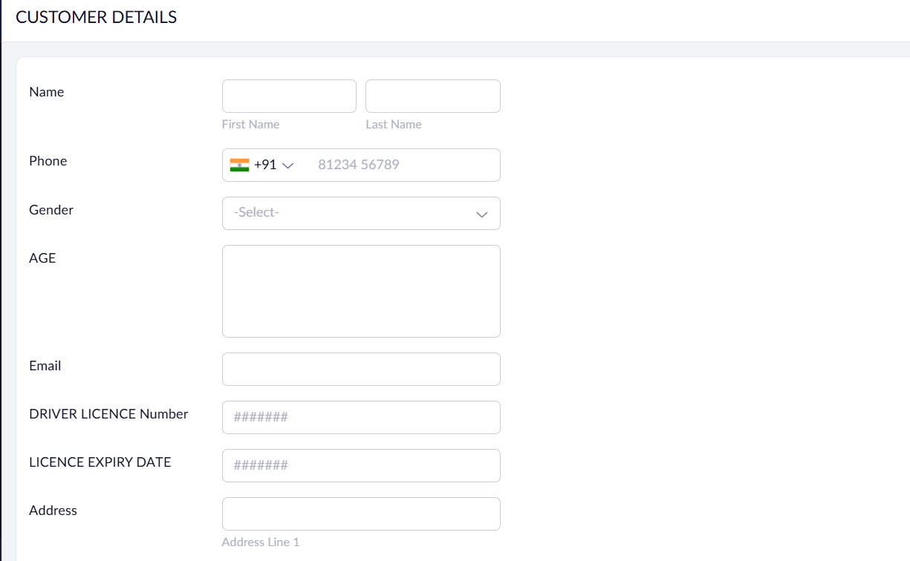

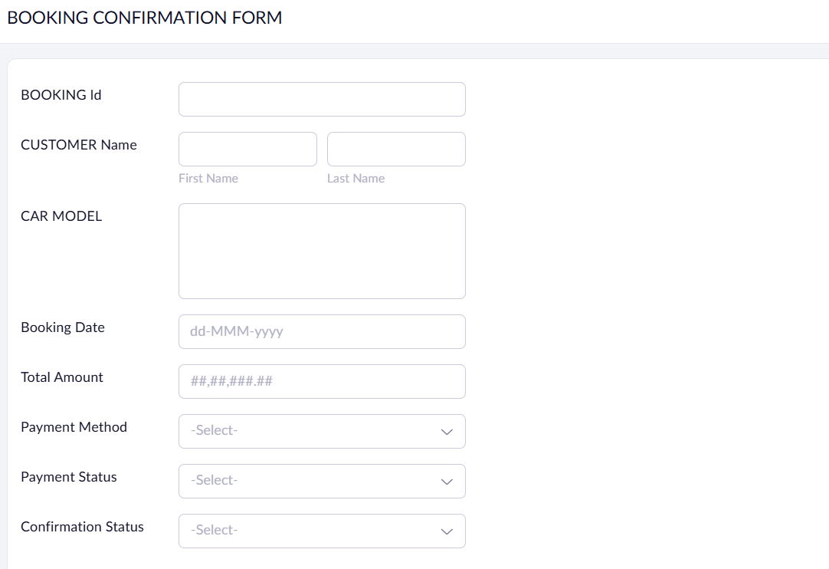

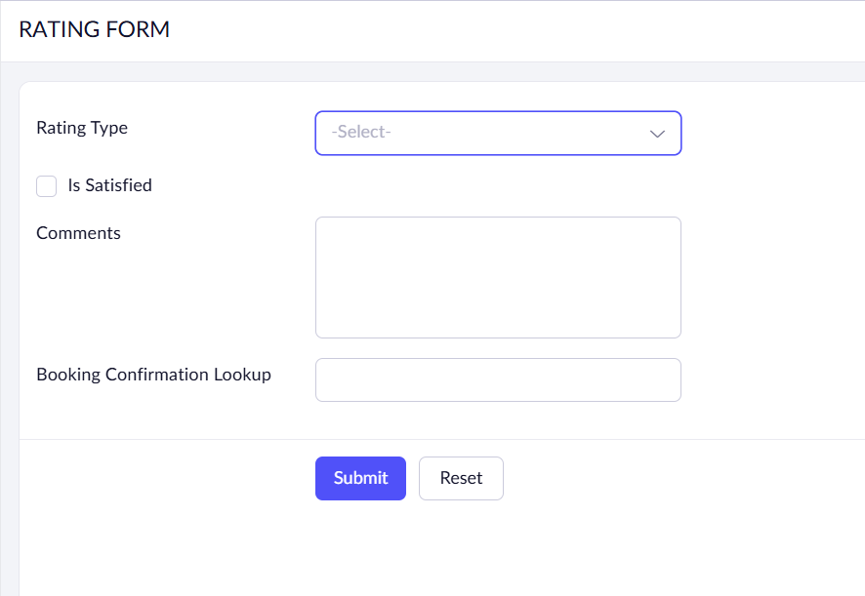

Results:

